Material Length Calculation via Dancer Displacement

Owen Lu

Electroimpact Inc.

owenl@electroimpact.com

*Abstract*—Due to the structure of the dancer control loop, velocity and displacement are related through a linear differential equation. This allows one to calculate the displacement of the dancer given a velocity profile, or vice-versa. This paper will provide a method by which discrete time samples of the dancer position can be used to calculate payout. A refinement technique is also prepared in order to minimize error due to systematic diameter error.

# Simplified Control Loop

Due to the structure of the control loop, higher order dynamics caused by the servo position control loop can be ignored. This greatly simplifies the calculations as the order of the differential equations are reduced.

The dancer displacement can be calculated using the Laplace domain equation in Eq. 1.

Let

$x_{d}$ be the dancer displacement

$x_{r}$ be the set point

$v_{o}$ be the payout velocity

|  |  |  |
| --- | --- | --- |
|  | $$x_{d}=\frac{CP}{1+CP}x_{r}+\frac{P}{1+CP}v_{o}$$ | (1) |

Where

|  |  |  |
| --- | --- | --- |
|  | $$C=\frac{K_{e}}{τs+1}$$ | (2) |
|  | $$P=\frac{1}{2s}$$ | (3) |

*Note that the issue of dancer threshold in the control loop will also be addressed in the later part of this paper.

We can easily rearrange Eq. 1 for $x_{o}=v_{o}/s$ and change it into time domain.

|  |  |  |
| --- | --- | --- |
|  | $$x_{0}\left(τs^{2}+s\right)=2x_{d}\left(τs^{2}+s\right)+K_{e}\left(x_{d}-x_{r}\right)$$ | (4) |
|  | $$x_{0}^{''}=-\frac{1}{τ}x_{o}^{'}+\frac{1}{τ}\left(K_{e}x_{d}+2x_{d}^{'}+2τx_{d}^{''}-K_{e}x_{r}\right)$$ | (5) |

This allows the state space equation to be written in time domain. A state space representation can be obtained at this point.

Let

|  |  |  |
| --- | --- | --- |
|  | $$x=\left[\begin{matrix}x_{o} \\ x_{o}'\end{matrix}\right]$$ | (6) |
|  | $$u=\left[\begin{matrix}x_{d} \\ x_{d}^{'} \\ x_{d}^{''} \\ x_{r}\end{matrix}\right]$$ | (7) |
|  | $$A=\left[\begin{matrix}0 & 1 \\ 0 & -\frac{1}{τ}\end{matrix}\right]$$ | (8) |
|  | $$B=\left[\begin{matrix}0 & 0 & 0 & 0 \\ \frac{K_{e}}{τ} & 2 & \frac{2}{τ} & -\frac{K_{e}}{τ}\end{matrix}\right]$$ | (9) |
|  | $$x^{'}=Ax+Bu$$ | (10) |

# Conversion to Discrete Time

State space representation is not immediately useful for real time calculations and must be converted to discrete time. The objective is to numerically solve the Initial Value Problem (IVP) with a constant time step. One way to do this in real time is the Euler method to differential equations. This is practical since the control vector will not be known in advance as it requires dancer readings.

|  |  |  |
| --- | --- | --- |
|  | $$x_{k}=x_{k-1}+x_{k-1}^{'}⋅Δt$$ | (11) |

Substitution of Eq. 6 into Eq. 7

Let

$I^{2}$ be the 2 $×$ 2 identity matrix

|  |  |  |
| --- | --- | --- |
|  | $$x_{k}=x_{k-1}+(Ax_{k-1}+Bu_{k-1})⋅Δt$$ | (12) |
|  | $$x_{k}=(\left(AΔt+I^{2}\right)x_{k-1}+BΔtu_{k-1})⋅$$ | (13) |
|  | $$F=\left(AΔt+I^{2}\right)$$ | (14) |
|  | $$G=BΔt$$ | (15) |
|  | $$x_{k}=Fx_{k-1}+Gu_{k-1}$$ | (16) |

Using the differential equation method, we can see that errors the displacement can have large peaks during payout due to rapid acceleration, but good steady state performance due to the cycling of the velocities since velocity must start and stop at zero during a payout.

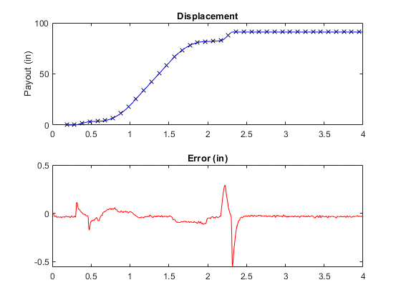

# Piecewise Controller Adjustment

In the current implementation of the dancer control loop on the H16EXP head, a piecewise controller is used. Based purely on the dancer position, a threshold causes the controller to switch behavior to a higher gain at higher speeds creating a non-linear system. However, the same non-linear system can be converted into a linear system with changing control inputs.

The implementation used is to change the set point $x_{r}$ based on the dancer via the piecewise equation.

|  |  |  |
| --- | --- | --- |
|  | $$x_{r}\left(x_{d}\right)=\left\{\begin{matrix}C & for x<x_{t} \\ C+x_{r}-x_{d} & for x>x_{t}\end{matrix}\right.$$ | (17) |

Where $C$ is the nominal position of the dancer set by the user. This can be also thought of as the lowest dancer displacement, which occurs if the machine is not paying out.

# Refinement via System identification

One key point in the previous model is that the diameter is not included in the calculation. This is due to the fact that a diameter measurement scales the control velocity so that the proper surface speed is set. If this diameter is incorrect then the dancer displacement in the model will also have a systematic discrepancy based on a gain factor.

The system identification is done by using the command payout velocity signal and predicting the dancer displacement. One state space representation in time domain uses Eq. 18-21.

Let

|  |  |  |
| --- | --- | --- |
|  | $$x_{d}=\left[\begin{matrix}x_{d} \\ x_{d}'\end{matrix}\right]$$ | (18) |
|  | $$u_{d}=\left[\begin{matrix}v_{o} \\ v_{o}' \\ x_{r}\end{matrix}\right]$$ | (19) |
|  | $$A_{d}=\left[\begin{matrix}0 & 1 \\ -\frac{K_{e}}{2τ} & -\frac{1}{τ}\end{matrix}\right]$$ | (20) |
|  | $$B_{d}=\left[\begin{matrix}0 & 0 & 0 \\ \frac{1}{2τ} & \frac{1}{2} & \frac{K_{e}}{2τ}\end{matrix}\right]$$ | (21) |

Using Eq. 13 the equation can be converted to discrete time in the same manner. The goal is to use measured dancer signals to identify the control constants $K_{e}$ and $τ$ experimentally.

For a given time series of dancer displacements stored in $Y$, minimize the squared error ${\left\|σ\right\|}^{2}$ between the model outputs $X$ with respect to .

|  |  |  |
| --- | --- | --- |
|  |  | (22) |

Finding the values of $K_{e},τ$ can be done by a Gauss-Newton method using numerical derivatives with respect to $K_{e},τ$.

Using a central derivative this involves 5 computations or simulations to formula a data vector $X$.

|  |  |  |
| --- | --- | --- |
|  | $$\frac{∂σ}{∂K_{e}}=\frac{1}{2h}\left(X\left(K_{e}-h,τ\right)-X\left(K_{e}+h,τ\right)\right)$$ | (23) |
|  | $$\frac{∂σ}{∂τ}=\frac{1}{2h}\left(X\left(K_{e},τ-h\right)-X\left(K_{e},τ+h\right)\right)$$ | (24) |

Note that $X$ is a column vector of predicted dancer positions. The partial derivatives of $σ$ are also column vectors. Suppose that there are $n$ data points in the set used for identification.

Let

|  |  |  |
| --- | --- | --- |
|  | $$β=\left[\begin{matrix}K_{e} \\ τ\end{matrix}\right]$$ | (25) |
|  | $$J=\left[\begin{matrix}\frac{∂σ_{1}}{∂K_{e}} & \frac{∂σ_{1}}{∂τ} \\ ⋮ & ⋮ \\ \frac{∂σ_{n}}{∂K_{e}} & \frac{∂σ_{n}}{∂τ}\end{matrix}\right]$$ | (26) |

Iteration for refined $β^{s}$ values is done via Eq. 27.

|  |  |  |
| --- | --- | --- |
|  | $$β^{s}=β^{s-1}-{\left(J^{T}J\right)}^{-1}J^{T}σ(β^{s-1})$$ | (27) |

A very important aspect of this system identification is that it can be done after every course. The reason is that the cycle includes velocity profiles well approximated by steps, and ramps allowing the low order characteristics of the system to be shown with good detail. Assuming that the gain is incorrect due to diameter measurement we can write the Eq. 28

|  |  |  |
| --- | --- | --- |
|  |  | () |

One the scale factor $K_{s}$ has been solved via iterating Eq. 27 then we can correct the diameter measurement by a factor in Eq. 29.

|  |  |  |
| --- | --- | --- |
|  |  | () |

# Refinement Experiment

Using a simulation with a known gain that was estimated incorrectly by 10%, the identification was run to see if the scale factor of the gain could be corrected and applied. The dancer measurement had Gaussian noise added to the signal to make the simulation more realistic with the function. The radius measurement also had Gaussian noise added to the signal with mean

Let

$Ν(μ,ϵ)$ be the normal distribution with $μ$ mean $ϵ$ standard deviation

|  |  |  |
| --- | --- | --- |
|  |  | () |
|  |  | () |

Note that all measurements are in inches. From Figure 1 the results show that the identification can provide very close dancer results. The diameter is predicted correctly to 0.5% with an initial 10% estimate error.

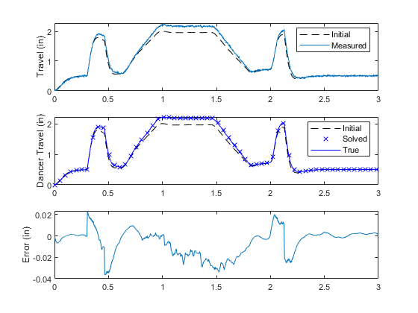

Figure 1 - System Identification Test

# Further study

The reason state space equation is also provided is to provide an easy way to integrate multiple measurements in the future. For example, it has been proposed that encoders be used to measure both dancer displacement and redirect rotations. These measurements can then be combined with a Kalman filter to provide a statistically optimal weighted prediction.